**Molecular Evolution Project: Human Respirovirus**

**Abstract**

HPIVs cause a significant load of disease in children, as well as in adults. A wide spectrum of illness including colds, croup, bronchiolitis, and pneumonia are attributed to these omnipresent pathogens. It includes Human Respirovirus 1, Human Respirovirus 3, Bovine Respirovirus 3, Caprine Respirovirus 3, and Murine Respirovirus. This study is based on research on Human respirovirus, on the sequences Human respirovirus 1, Human respirovirus 3 and Simian Agent 10 strains. Analysis that are done summarized the number of mutations, transitions, transversions, gaps, insertions, deletions, and similarities. Using these results, we can see how mutations occurred and are there are any gaps created.

**Introduction**

Parainfluenza viruses (PIVs) are known as the virus paramyxoviruses, from the family Paramyxoviridae, and the subfamily Paramyxovirinae. Human PIVs (HPIVs) are simply divided into 5 serotypes: HPIV-1, HPIV-2, HPIV-3, HPIV-4a, and HPIV-4b, and in 2 different genera: Respirovirus: HPIV-1 and HPIV-3, and Rubulavirus: HPIV-2 and HPIV-4 [1]. These viruses mostly affect young children, including upper and lower respiratory tract infections. They produce about 30%-40% of all acute respiratory tract infections in infants, as well as in children. Usually symptoms are cold with fever, bronchiolitis, and pneumonia [1]. HPIV can be easily transmitted through a sneeze, but also getting in contact with infectious material, and later touching eyes, mouth, or nose. The virus can easily live in the air for an hour [2]. Still there is no vaccine to prevent HPIV infection, but scientists are working on it. These illnesses are mild and they require only treatment of symptoms, so they do not have any specific treatment [3].

Human respirovirus 1 is a single-stranded, negative-sense RNA virus in the family Paramyxoviridae that causes infections and diseases in humans, mostly children [4]. The genus respirovirus includes members with genomes of 15500 nucleotides long, such as human respirovirus 1, human respirovirus 3, bovine respirovirus 3, caprine respirovirus 3, and murine respirovirus [4].

**Materials and Methods**

The study is based on research on Human respirovirus. The sequences Human respirovirus 1, Human respirovirus 3 and Simian Agent 10 strains of Human respirovirus were taken from the GenBank (NCBI) and NIH sites. Then the four of them were combined and a Clustal Omega multiple sequence alignment was performed. There is a loaded fasta format with all four virus sequences, ClustalW is chosen as the output, and the order to be the input. The first analysis of the data was done using a python script by a professor. This analysis summarized the number of mutations / transitions / transversions / gaps / insertions / deletions / similarities. My statistical analysis was done on these results using excel. Comparisons of mutations through strains were performed. Also, comparison between coding and non-coding regions of the virus was also done in order to get better picture of a project. After all these methods were done, I got the results which can be seen below.

**Results and Discussion**

My statistical analysis was done on these results using excel. Comparisons of mutations through strains were performed. I compared 4 genomes of Human Respirovirus and the difference is recorded here.

As we can see, genome 1 does not have any mutation accumulated in the whole sequences. Also, the coding and noncoding sequences got the same results as whole sequence which is zero mutations. This happens because there are no insertion or deletion or substitution of the nucleotides in the genome sequence. When we look to the Mutations in the Coding sequences, we can see that there are no gaps in the coding sequence, which means that there are no insertion or deletion of the nucleotide. In this case there is no frame shifting mutations happen in the coding sequence, but the mutation is caused by the substitution of the nucleotides either by transition or transversion, and that will lead to point mutation.

Now, when we look to other 3 genomes, we can see that there is no a big difference between them. Third genome has 6842 mutations where 5873 of them are accumulated in coding sequence and 969 mutations accumulated in the noncoding sequence. Second one has 6813 mutations where 5857 of them are accumulated in coding sequence and 956 mutations accumulated in the noncoding sequence. And the fourth one is the smallest of these three, having 6812 mutations where 5836 of them are accumulated in coding sequence and 976 mutations accumulated in the noncoding sequence.

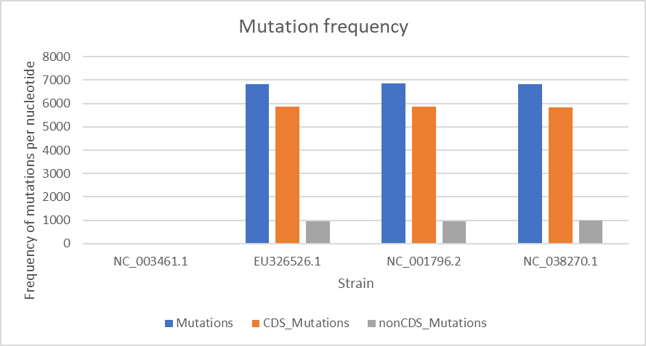  
Figure 1. Mutation frequency

A gap is representing the missing bases in the sequences. They can be created by insertion (inserting a nucleotide) and deletion (deleting the nucleotide). The gaps are made in specific location to gain or loss large section of DNA. I analyzed and compared 4 genomes of Human respirovirus for the alignment gaps.

As we can see, genome 1 does not have any gap in the whole sequence, no insertion or deletion. The coding and non-coding sequence have the same results as whole sequence which is zero.

When we are looking at coding sequences of those 4 genomes, we can see that first genome has zero gaps in it, but other three have the same number of 152 gaps in it.

Other three genomes showed the non-coding sequence with both insertion and deletion. In total, there are 514 gaps, where 250 is due to insertion and 264 gaps happened because of deletion.

The gaps are located on the genome, so the genome is going through mutation or gene silencing depending on the process.

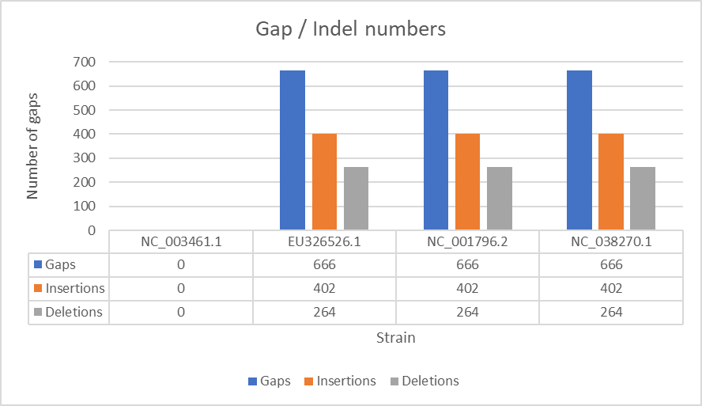  
Figure 2. Gap/Indel numbers

**Conclusion**

HPIVs cause a significant load of disease in children, as well as in adults. A wide spectrum of illness including colds, croup, bronchiolitis, and pneumonia are attributed to these omnipresent pathogens. It includes Human Respirovirus 1, Human Respirovirus 3, Bovine Respirovirus 3, Caprine Respirovirus 3, and Murine Respirovirus. This study is based on research on Human respirovirus, on the sequences Human respirovirus 1, Human respirovirus 3 and Simian Agent 10 strains. Analysis that are done summarized the number of mutations, transitions, transversions, gaps, insertions, deletions, and similarities. Using these results, we can see how mutations occurred and are there are any gaps created.

**References**

|  |  |  |
| --- | --- | --- |
| [1] |  | M. M. P. D. F. Subhash Candra Parija, "Medscape," 30 September 2020. [Online]. Available: https://emedicine.medscape.com/article/224708-overview. |
| [2] |  | M. E. Ellis, "Parainfluenza," 17 September 2018. [Online]. Available: https://www.healthline.com/health/cold-flu/parainfluenza. |
| [3] |  | M. Angela R. Branche and A. R. Falsey, "Parainfluenza Virus Infection," *NCBI,* no. 538-554, p. August, 2016. |
| [4] |  | M. Scotch, R. U. Halden, A. Denton, H. Sandrolini, R. S. Fontenele and A. Varsani, "Coding-Complete Genome Sequence of a Human Respirovirus 1 Strain from a Clinical Sample in Ariozna," *Journals ASM,* 2020. |